**Carbon dioxide (CO2) flooding system**

Fire suppression systems are designed to suppress or extinguish a fire in sensitive environments where water from a [**fire sprinkler**](https://blog.koorsen.com/the-history-and-importance-of-fire-sprinkler-systems) is not a desired extinguishing agent. Common areas where you will find fire suppression systems include server rooms, engine rooms, flammable storage areas, museums, and data centers.

CO2 is a colorless, odorless, and electrically non-conductive gas that leaves no residue behind. This means any sensitive equipment that is in the protected space is not damaged by the CO2, which reduces downtime and costs. Once the CO2 has dispersed to safe levels from the protected space, personnel can access any damage from the fire or smoke and quickly get back to work with no cleanup needed.

Carbon dioxide is a standard commercial product that is commonly used for carbonated beverages, for fast freezing food, for medical purposes, for purging pipes and tanks, as well as for extinguishing fi res. It is readily available in most cities and seaports throughout the world. For more than 80 years carbon dioxide has been used for fi re protection purposes. The NFPA standard for fi re extinguishing systems was initiated in 1928, was fi rst adopted in 1929. It has been revised approximately 26 times since, and represents the accumulated knowledge and

experience of those who have designed and used CO2 systems for fi re extinguishing

purposes.

**Properties of CO2 as a Fire Extinguishing Agent**

1. Carbon Dioxide (CO2) is a colorless, odorless, clean, dry, electrically non-conducting, non-corrosive, non-damaging and nondeteriorating inert gas, that is approximately 50 percent heavier than air.
2. Carbon dioxide is a standard commercial product. It is commonly used for carbonating beverages, for fast freezing food, for medical purposes, and for purging pipes and tanks, as well as for extinguishing fi res. Carbon dioxide is available in most cities and seaports throughout the world.
3. When inhaled, CO2 produces a tingle in the nostrils, the same as is experienced when drinking carbonated beverages. Carbon Dioxide stimulates breathing (increases the rate of breathing), and is useful in small controlled doses in the resuscitation of drowning and electric shock victims.
4. Carbon Dioxide is stored in liquid form in high pressure steel containers, usually at 850 psig at 70 °F (58 bar at 21 °C). It may also be stored at 300 psig at 0 °F (20 bar at -18 °C), for special large requirements.
5. One of carbon dioxide’s most valuable properties is its amazing high ratio of expansion, approximately450 to 1. Carbon dioxide is discharged from the cylinder by the force of its own expansion – without the need for pumps or other pressurizing mechanisms. Carbon dioxide will penetrate every nook and corner of a space where fi re might lurk. On discharge, carbon dioxide creates a cold fog. The temperature of carbon dioxide discharging from a nozzle is approximately 110 °F below zero. This cloud effect, or fogging, is due to the moisture in the air being frozen by the extremely low temperature of the Carbon Dioxide and fi ne “snow” accompanying the discharge. The fogging will generally dissipate after a few minutes.

At 7.5% concentration, CO2 can cause asphyxiation to humans. Most CO2 fire suppression systems are designed to have 34% CO2 concentrations for a total flood of the protected space. Due to the obvious dangers of CO2, the CO2 fire suppression systems are required to have certain life safety devices to protect personnel around or near the protected spaces. One of the life safety devices is a pneumatic siren that warns people around the area that the CO2 will be discharging from the suppression system. It is important to properly train all personnel on the dangers of the CO2 fire suppression system and how to evacuate safely if the system is preparing to dump the CO2 to suppress the fire.

 A fixed installation designed to displace the oxygen in the protected space and thus extinguish the fire, usually used to fight fires in engine rooms, boiler rooms, pump rooms and holds. The system normally consists of a series of large CO2 cylinders. The CO2 is supplied from the cylinder manifold to suitable points with diffusing nozzles. The discharge valve is located in a locked cabinet. Opening the cabinet activates an alarm to give personnel time for evacuation. Since the effectiveness of fixed CO2 fire fighting system diminishes the longer the fire burns, the speed is essential if CO2 is to be effective.

**Note**: Before CO2 system can be activated, engines need to be shut off, the machinery space needs to be evacuated, all openings and vent need to be shut and total evacuation has to be verified. Consequently, it can take 20 minutes or longer from the time of a fire is spotted to activate the system. Such delay not only allows fire to spread freely causing considerable danger to personnel and damage to equipment, but also makes a vessel lose its manoeuvrability.

Dangers: **CO2 extinguishers should not be used** on **fires** involving solid materials, such as paper, wood and fabric, and also are **not** suitable for **use** on flammable gases.

The **carbon dioxide considered** the best **fire extinguisher** to put off **fires** caused by burning of inflammable liquids such as petrol or oil because **carbon dioxide** stops the influence of oxygen because it decreases the oxygen present in that **fire** which leads to the fallout of **fire**.

**CO2 Safety Precautions**

Safeguards must be taken to ensure the safety of personnel in areas where the atmosphere could be made hazardous by the discharge of carbon dioxide. The following list, which is strongly recommended, is

generally taken from NFPA 12: Standard on Carbon Dioxide Extinguishing Systems.

a) Provide adequate aisleways and routes of exit and keep them clear at all times.

b) Provide emergency lighting and directional signs as necessary to ensure quick, safe evacuation.

c) Provide alarms within such areas that will operate immediately upon detection of the fi re, with the discharge of the carbon dioxide and the activation of automatic door closures delayed for suffi cient time to allow evacuation of the area before discharge begins.

d) Provide only outward swinging selfclosing doors at exits from hazard areas, and, where such doors are latched, providepanic hardware

e) Provide continuous alarms at entrances to such areas until the atmosphere has been restored to normal.

f) Provide warning and instruction signs at entrances to and inside such areas. These signs should inform persons in, or entering the protected area that a carbon dioxide system is installed, and may contain

additional instructions pertinent to the conditions of the hazard.

g) Provide for the prompt discovery and rescue of persons rendered unconscious in suchareas. This may be accomplished by having such areas searched immediately by trained persons equipped with proper

breathing equipment. Self-contained breathing equipment (and personnel trained in its use, and in rescue practices, including artifi cial respiration), should be readily available.

h) Provide instruction and drills for all personnel within or in the vicinity of such areas including maintenance or construction people who may be brought into the area), to ensure their correct

action when carbon dioxide protective equipment operates.

i) Provide the means for prompt ventilation of such areas. Forced ventilation will often be necessary.

Care should be taken to really dissipate hazardous atmospheres and not merely move them to another location.

j) Carbon dioxide is much heavier than air and can collect in pits, cellars and lowlying

areas. Care should be taken when entering such areas after carbon dioxide has been discharged.

k) Provide means to lock off or disarm the system during periods of system inspection, maintenance, or modifi cation.

I) Provide such other steps and safeguards that a careful study of each particular situation indicates are necessary to prevent injury or death

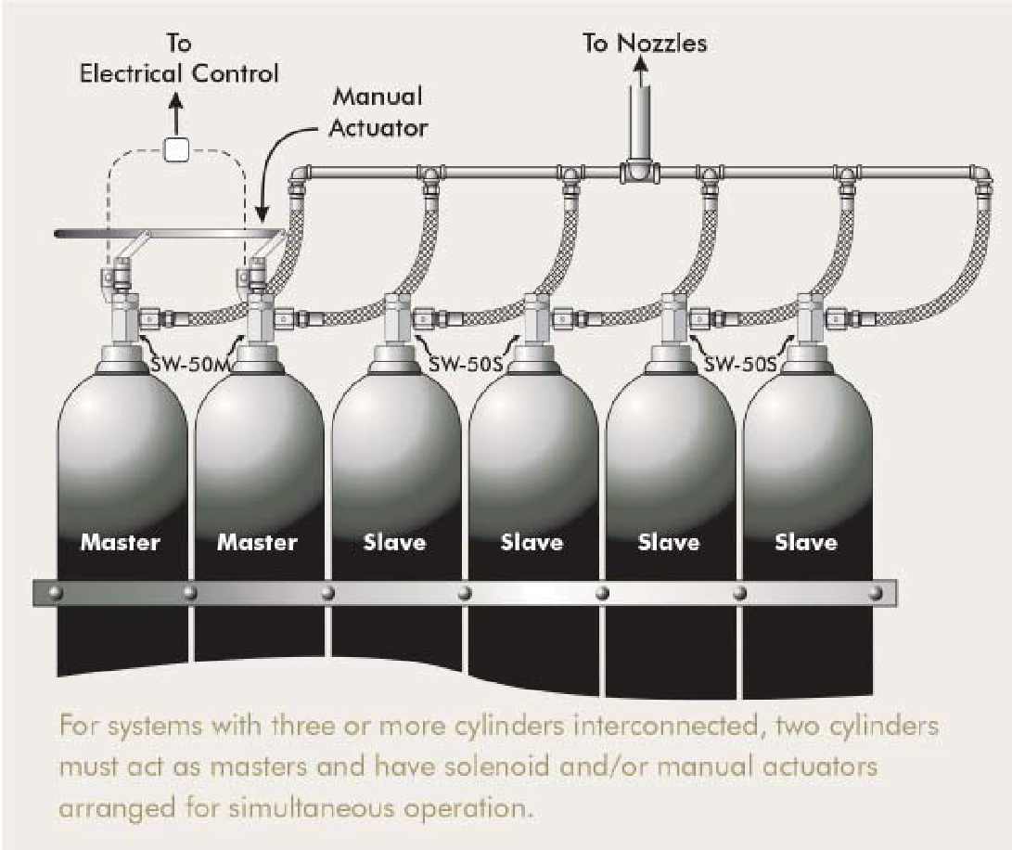

A fire extinguishing systems is an engineered set of components that work together to quickly detect a fire, alert occupants, and extinguish the fire before extensive damage can occur. All system components must be:

* Designed and approved for use on the specific fire hazards they are expected to control or extinguish. [[29 CFR 1910.160(b)(1)](https://www.osha.gov/pls/oshaweb/owadisp.show_document?p_table=STANDARDS&p_id=9814#1910.160(b)(1))]
* Protected against corrosion or either made or coated with a non-corrosive material if it may be exposed to a corrosive environment. [[29 CFR 1910.160(b)(12)](https://www.osha.gov/pls/oshaweb/owadisp.show_document?p_table=STANDARDS&p_id=9814#1910.160(b)(12))]
* Designed for the climate and temperature extremes to which they will be exposed. [[29 CFR 1910.160(b)(14)](https://www.osha.gov/pls/oshaweb/owadisp.show_document?p_table=STANDARDS&p_id=9814#1910.160(b)(14))]

Typical elements and components include:

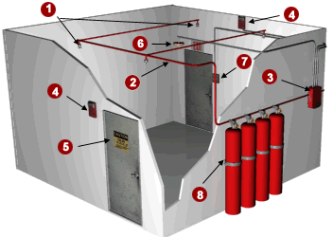

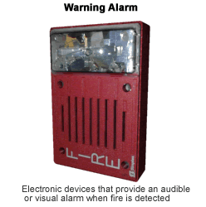

1. [Discharge Nozzles](https://www.osha.gov/SLTC/etools/evacuation/fixed.html#discharge_nozzle)  
   Discharge nozzles are used to disperse the extinguishing agent into the protected area.
2. [Piping](https://www.osha.gov/SLTC/etools/evacuation/fixed.html#piping)  
   The piping system is used to transport the extinguishing agent (carbon dioxide, halon, argon, etc) from its storage container to the discharge nozzle.
3. [Control Panel](https://www.osha.gov/SLTC/etools/evacuation/fixed.html#control_panel)  
   The control panel integrates all devices and displays their operational status and condition.
4. [Discharge or Warning Alarm(s)](https://www.osha.gov/SLTC/etools/evacuation/fixed.html#discharge)  
   Electronic devices that provide an audible or visual alarm when detected.
5. [Hazard Warning or Caution Signs](https://www.osha.gov/SLTC/etools/evacuation/fixed.html#warning)  
   Hazard warning signs must be posted at the entrance to, and inside, areas protected by fixed extinguishing systems.
6. [Automatic Fire Detection Device(s)](https://www.osha.gov/SLTC/etools/evacuation/fixed.html#fire_detectors)  
   A device that detects fire and causes an alarm signal to be generated.
7. [Manual Discharge Station(s)](https://www.osha.gov/SLTC/etools/evacuation/fixed.html#manual_discharge)  
   A device that provides a way to manually discharge the fire extinguishing system.
8. [Storage Container(s) & Extinguishing Agent](https://www.osha.gov/SLTC/etools/evacuation/fixed.html#extinguishing_agent)  
   The storage system discharges agent into the piping and through the discharge nozzles when activated by a manual or automatic device.

*NOTE*: Use your mouse to explore the picture above. Hover over any number to go to that component's requirements.

**Discharge Nozzles:**

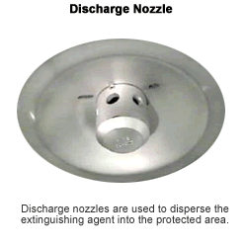

*Discharge Nozzles. Discharge nozzles are used to dispense the extinguishing agents into the protected area.*

A discharge nozzle is a device designed to release the extinguishing agent at a specific rate and pattern to quickly extinguish a fire. Discharge nozzles must be suitable for the fire it is intended to extinguish. [[29 CFR 1910.160(b)(1)](https://www.osha.gov/pls/oshaweb/owadisp.show_document?p_table=STANDARDS&p_id=9814#1910.160(b)(1))]

The nozzle pictured is designed for total flooding applications. Its bell shape and multiple small discharge openings will create a widely dispersed and diffused discharge pattern to quickly flood an enclosed area with an extinguishing agent. This type of nozzle is common in paint spray booths, flammable liquid storage rooms or other similar areas.

Nozzles designed for local application usually consist of a cylindrical body with a straight unobstructed center opening. This type of nozzle produces a small discharge pattern that directs the agent toward a local application such as paint dip tanks, quench tanks or areas where a flammable liquid spill may occur.

**Piping:**

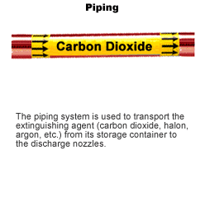

*Piping. The piping system is used to transport the extinguishing agent (carbon dioxide, halon, argon, etc.) from its storage container to the discharge nozzles.*

The piping network is designed to properly distribute the extinguishing agent to the protected areas. All fire protection systems must have pipes and fittings that are suitable for the expected temperature extremes with good corrosion resistance properties.

**Control Panel:**

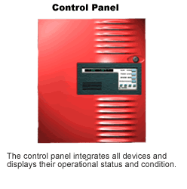

*Control Panel. The control panel integrates all devices and displays their operational status and condition.*

The control panel monitors and integrates all components together and controls the audible and visual alarms and discharge functions. When an automatic or manual device is activated it sends a signal to the control panel where, depending on the type of system and hazards, can be programmed to:

* Activate a pre-discharge alarm.
* Initiate agent release.
* Shutdown ventilation systems.
* Shutdown machinery or equipment.
* Activate visual and audible fire alarms.
* Notify emergency response personnel.

**Discharge Alarm or Signaling Devices:**



*Warning Alarm. Electronic devices that provide an audible or visual alarm when fire is detected.*

Each area protected by a fixed extinguishing system must have a distinctive alarm or signal which complies with [29 CFR 1910.165](https://www.osha.gov/pls/oshaweb/owadisp.show_document?p_table=STANDARDS&p_id=9819) to alert occupants that the system is discharging. These alarms must be able to be heard or seen above ambient noise or light levels, unless the discharge is immediately recognizable. [[29 CFR 1910.160(b)(3)](https://www.osha.gov/pls/oshaweb/owadisp.show_document?p_table=STANDARDS&p_id=9814#1910.160(b)(3))]

If the alarm or signaling device is used on a total flooding system, it must also:

* Alarm before the system discharges, to give employees sufficient time to safely exit the space. [[29 CFR 1910.160(c)(3)](https://www.osha.gov/pls/oshaweb/owadisp.show_document?p_table=STANDARDS&p_id=9814#1910.160(c)(3))]
* Be connected to an approved fire detection device that automatically activates the pre-discharge alarm prior to the system discharge. [[29 CFR 1910.160(c)(4)](https://www.osha.gov/pls/oshaweb/owadisp.show_document?p_table=STANDARDS&p_id=9814#1910.160(c)(4))]
* Be addressed in an emergency action plan in accordance with [29 CFR 1910.38](https://www.osha.gov/pls/oshaweb/owadisp.show_document?p_table=STANDARDS&p_id=9726) for each area that is protected.

*NOTE*: Areas protected by a total flooding system where employees cannot enter during or after the system's operation are exempt from the requirements of [29 CFR 1910.160(c)](https://www.osha.gov/pls/oshaweb/owadisp.show_document?p_table=STANDARDS&p_id=9814#1910.160(c)) of this section. [[29 CFR 1910.160(c)(2)](https://www.osha.gov/pls/oshaweb/owadisp.show_document?p_table=STANDARDS&p_id=9814#1910.160(c)(2))]

**Warning Signs and Safeguards**

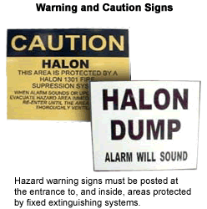

*Warning and Caution Signs. Hazard warning signs must be posted at the entrance to, and inside, areas protected by fixed extinguishing systems.*

Warning signs must be posted to warn employees in advance about the hazards associated with the extinguishing agent. Hazard warning or caution signs must be posted at the entrance to and inside of areas protected by fixed extinguishing systems which use agents in concentrations known to be hazardous to employee safety and health. [[29 CFR 1910.160(b)(5)](https://www.osha.gov/pls/oshaweb/owadisp.show_document?p_table=STANDARDS&p_id=9814#1910.160(b)(5))]

Recommended guidelines for posting:

* To avoid confusion, keep hazard warning signs consistent by using standardized patterns, phrases, colors, shapes and pictures.
* Wording on signs should be concise, easy to read, and contain sufficient information that is easily understood.
* Warning signs must be in English and should also be posted in the native language spoken by the employees.

In addition to warning signs, the employer must also provide effective safeguards to warn employees when the atmosphere of a protected area remains hazardous to their safety or health as a result of a system discharged. [[29 CFR 1910.160(b)(4)](https://www.osha.gov/pls/oshaweb/owadisp.show_document?p_table=STANDARDS&p_id=9814#1910.160(b)(4))]

**Automatic Fire Detectors:**

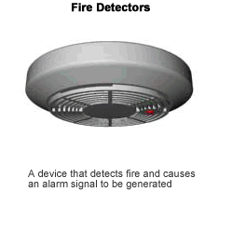

*Fire Detectors. A device that detects fire and causes an alarm signal to be generated.*

Automatic detection devices sense the smoke, heat, or flames from a fire and initiate an alarm. All automatic detection equipment must be approved, installed and maintained in accordance with [29 CFR 1910.164](https://www.osha.gov/pls/oshaweb/owadisp.show_document?p_table=STANDARDS&p_id=9818).

Automatic detection devices used on a total flooding system must:

* Automatically activate the pre-discharge alarm before the system discharges to give employees time to safely exit from the protected area. [[29 CFR 1910.160(c)(4)](https://www.osha.gov/pls/oshaweb/owadisp.show_document?p_table=STANDARDS&p_id=9814#1910.160(c)(4))]

Note: Areas protected by a total flooding system where employees cannot enter during or after the system's operation are exempt from the requirements of [29 CFR 1910.160(c)](https://www.osha.gov/pls/oshaweb/owadisp.show_document?p_table=STANDARDS&p_id=9814#1910.160(c)) of this section. [[29 CFR 1910.160(c)(2)](https://www.osha.gov/pls/oshaweb/owadisp.show_document?p_table=STANDARDS&p_id=9814#1910.160(c)(2))]

**Manual Discharge Station:**

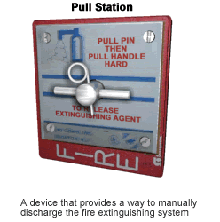

*Pull Station. A device that provides a way to manually discharge the fire extinguishing system.*

A manual discharge station is a device usually mounted on a wall near the emergency exit(s) which will automatically sound an alarm and release the extinguishing agent. If your workplace is equipped with a fixed suppressant system, there must be at least one manual station for each protected area. [[29 CFR 1910.160(b)(15)](https://www.osha.gov/pls/oshaweb/owadisp.show_document?p_table=STANDARDS&p_id=9814#1910.160(b)(15))]

Pull Station Guidelines:

* Properly mark and/or label pull stations and other activation devices to indicate their function and the potential hazard to personnel. [[29 CFR 1910.160(b)(16)](https://www.osha.gov/pls/oshaweb/owadisp.show_document?p_table=STANDARDS&p_id=9814#1910.160(b)(16))]
* Pull stations must be clearly visible (not blocked or covered) and located near exits or escape routes.
* Post operating instructions at each station.
* Train employees to know when, where, and how to use pull stations.
* Determine, if possible, if someone is in the area and get them out before using a manual discharge station.

**Extinguishing Agent Storage Containers:**

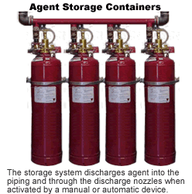

*Agent Storage Containers. The storage system discharges agent into piping and through the discharge nozzles when activated by a manual or automatic device.*

Storage containers hold the extinguishing agent until it is needed and can be high or low pressure cylinders or tanks. These containers can be used to hold specialized fire suppression agents like carbon dioxide or halon to protect special work areas, such as computer rooms, chemical storage, or similar areas.

Storage Container Requirements:

* Check the weight and pressure of refillable containers at least semi-annually. Maintain the the container if it shows a loss in net content or weight of more than 5 percent, or a loss in pressure of more than 10 percent. [[29 CFR 1910.160(b)(7)](https://www.osha.gov/pls/oshaweb/owadisp.show_document?p_table=STANDARDS&p_id=9814#1910.160(b)(7))]
* Weigh factory charged non-refillable containers that have no means of pressure indication at least semiannually. Replace the container if it shows a loss in net content or weight of more than 5 percent. [[29 CFR 1910.160(b)(8)](https://www.osha.gov/pls/oshaweb/owadisp.show_document?p_table=STANDARDS&p_id=9814#1910.160(b)(8))]
* Record inspection and maintenance dates on the container, on a tag attached to the container or in a central location. Maintain a record of the last semi-annual check until the container is checked again or for the life of the container, whichever is less. [[29 CFR 1910.160(b)(9)](https://www.osha.gov/pls/oshaweb/owadisp.show_document?p_table=STANDARDS&p_id=9814#1910.160(b)(9))]
* Do not use chlorobromomethane or carbon tetrachloride as an extinguishing agent in an area where employees may be exposed. [[29 CFR 1910.160(b)(11)](https://www.osha.gov/pls/oshaweb/owadisp.show_document?p_table=STANDARDS&p_id=9814#1910.160(b)(11))]

**HALON FLOODING SYSTEM**

Halon is a "Clean Agent." [The National Fire Protection Association](http://www.nfpa.org/index.asp) defines, a "Clean Agent" as "an electrically non-conducting, volatile, or gaseous fire extinguishant that does not leave a residue upon evaporation."

Halon is a liquefied, compressed gas that stops the spread of fire by chemically disrupting combustion. Halon 1211 (a liquid streaming agent) and Halon 1301 (a gaseous flooding agent) leave no residue and are remarkably safe for human exposure. Halon is rated for class "B" (flammable liquids) and "C" (electrical fires), but it is also effective on class "A" (common combustibles) fires. Halon 1211 and Halon 1301 are low-toxicity, chemically stable compounds that, as long as they remain contained in cylinders, are easily recyclable.

Halon is an extraordinarily effective fire extinguishing agent, even at low concentrations. According to the [Halon Alternative Research Corporation](http://www.harc.org/): "Three things must come together at the same time to start a fire. The first ingredient is fuel (anything that can burn), the second is oxygen (normal breathing air is ample) and the last is an ignition source (high heat can cause a fire even without a spark or open flame). Traditionally, to stop a fire you need to remove one side of the triangle - the ignition, the fuel or the oxygen. Halon adds a fourth dimension to fire fighting - breaking the chain reaction. It stops the fuel, the ignition and the oxygen from dancing together by chemically reacting with them."

A key benefit of Halon, as a clean agent, is its ability to extinguish fire without the production of residues that could damage the assets being protected. Halon has been used for fire and explosion protection throughout the 20th century, and remains an integral part of the safety plans in many of today's manufacturing, electronic and aviation companies. Halon protects computer and communication rooms throughout the electronics industry; it has numerous military applications on ships, aircraft and tanks and helps ensure safety on all commercial aircraft.

Because Halon is a CFC, production of new Halon ceased in 1994. There is no cost effective means of safely and effectively disposing of the Halon. Therefore, recycling and reusing the existing supply intelligently and responsibly to protect lives and property is the wisest solution.

### Halon Gas Effect on Humans

Overall, Halon is safe around humans and can be used in occupied spaces. Halon suppression systems became widely properly because Halon is a low-toxicity, chemically stable compound that does not damage sensitive equipment, documents, and valuable assets. Halon fire suppression systems are still used in places like computer and communication rooms and in several military applications, including on ships, aircrafts, and tanks. The FAA also continues to recommend Halon fire extinguishers for aircrafts because of its effectiveness and ability to be used in closed spaces.

### Halon Gas Replacement

While Halons 1301 and 1211 are excellent at extinguishing fires, they have the potential to deplete the ozone layer and contribute to global warming. In response to the end of the production of new Halons, alternative [clean agents](https://www.firetrace.com/fire-protection-blog/exploring-the-benefits-of-clean-agents) were developed. Two of the most popular Halon alternatives are [3M™ Novec™ 1230](https://www.firetrace.com/en/3m-novec-1230) and [FM-200™](https://www.firetrace.com/en/fm-200). These clean agents have similar benefits of Halon, including being able to be used in occupied spaces and not leaving a residue, so they are safe for equipment and minimize any downtime from a lengthy cleanup. The advantage over Halon is that both 3M™ Novec™ 1230 and FM-200™ have an Ozone Depletion Potential of 0 and will not cause harm to the ozone layer. Another clean agent option is CO2. CO2 will not harm the ozone layer or contribute to global warming, but the drawback of usingCO2 is that it displaces the oxygen to suppress the fire. This could lead to suffocation when used in occupied spaces. There are numerous Halon replacements out on the market. When selecting a clean agent [fire suppression system](https://www.firetrace.com/fire-suppression-systems), it is important to evaluate all of our options.

**COMPLETE DCP FLOODING**